**HOTEL BOOKING CANCELATION**

**Data Analysis Project**

**Project Overview:**

**This dataset contains 119390 observations for a City Hotel and a Resort Hotel. Each observation represents a hotel booking between the 1st of July 2015 and 31st of August 2017, including booking that effectively arrived and booking that were canceled.**

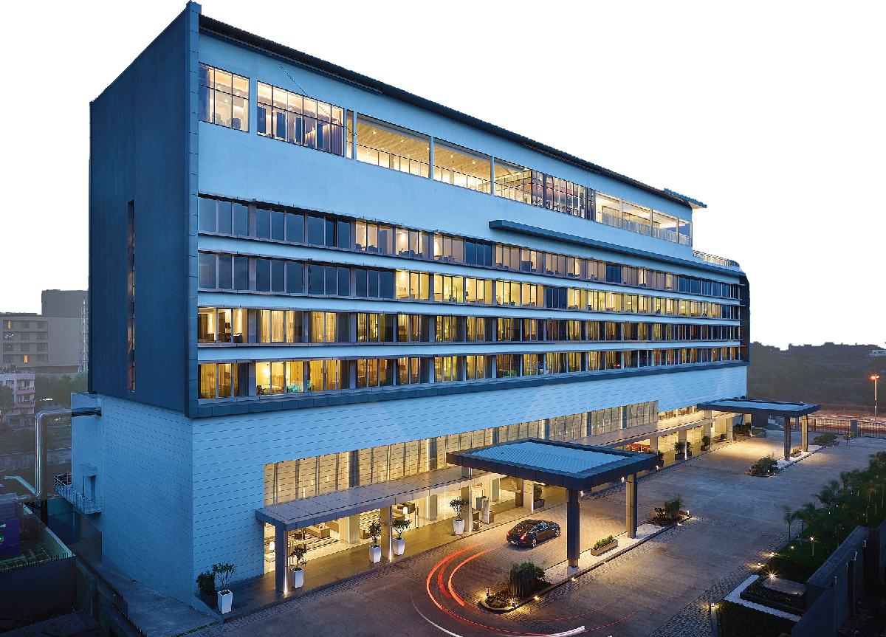

**Requirements**

**KPI CARDS**

* Find Total number of cancelation in resort hotel and city hotel .
* Find Total number of not Cancelled in resort hotel and city hotel.
* Find Total number of transactions.

**FILTER PANNEL**

* Filter Our report data with Country wise and Month wise.

**Charts Used in Our report**

* Show Cancelled booking and Not Cancelled booking by hotel wise in column chart.
* Show Cancelled booking and Not Cancelled booking by Month wise in column chart.
* Show Top 10 Cancelled booking by country wise in pie chart .
* Show Cancelled booking and Not Cancelled booking by Weekname wise in bar chart.
* Show Cancelled booking and Average daily rate by Month wise in line column chart.

**Questions:**

* Visualize the relationship between the number of required car parking

spaces and booking types (Resort Hotel vs. City Hotel).

* Explore meal plans and their impact on Average Daily Rates (ADR).

Analyze meal plan preferences and their association with booking channels.

* Visualize the Count of reserved room type by market segment and hotel type (Resort Hotel vs. City Hotel)
* Analyze trends in reservation status dates, such as the busiest

checkout dates or patterns in cancellations by month.

* Visualize the distribution of adults, children, and babies in bookings. and count adults, children, and babies according to market segment.
* Average of ADR By Country.